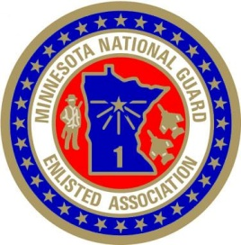
56th ANNUAL MNGEA
STATE BUSINESS MEETING AGENDA
The Lodge at Brainerd Lakes, Baxter, MN
11-12 April 2025

FRIDAY, 11 APRIL 2025
1800 - ??? No Host Social Baxter’s Bar & Grill

SATURDAY, 12 APRIL 2025
0600 – 0800 Breakfast Available Baxter Bar & Grill
0800 – 1100 FIRST BUSINESS SESSION Bait & Tackle Room
Conference Call to Order Mark Wasserbauer
Administrative Notes
Pledge of Allegiance All
Official Conference Roll Call
President’s Guidance
Rules and Credentials
Membership Report
Scholarship Report
By-Laws Report
Awards Committee Report
Guest Speakers
– MN Command Senior Enlisted Leader CSEL Lisa Erikson
– MN Command Sergeant Major CSM Jason Rost

1100 – 1200 LUNCH Baxter Bar & Grill

1200 – 1600 SECOND BUSINESS SESSION
Treasurer’s & Finance Committee Report
Insurance Committee Report
Legislative Committee Report
Resolutions Committee Report
Nominations Committee Report
Time & Place Report
1500 Report of the President
1530 NEW BUSINESS
Election of Board Officers

1600 ADJOLURNMENT

